User Guide
for
Space Adventure 3.0
Version 1.0 approved
Prepared by Ross Kahn
The Insight Lab at the Rochester Institute of Technology
March, 2013
Table of Contents
Table of Contents 1
Revision History 1
1. Installation 1
1.1 Celestia v1.6.1 1
1.2 Kinect SDK v1.6 1
1.3 Microsoft Speech SDK v11.0 2
2. Getting Started 2
3. How to Use Space Adventure 2
3.1 Keyboard/Mouse 2
3.1.1 Traveling to Different Planets 2
3.1.2 Rotating Planets 3
3.1.3 Zooming In on Planets 3
3.1.4 Zooming Out from Planets 3
3.2 Speech 4
3.2.1 Traveling to Different Planets 4
3.3 Motion 4
3.3.1 Rotating a Planet 4
3.3.2 Zooming In on a Planet 4
3.3.3 Zooming Out from a Planet 4

Revision History
Name | Date | Reason For Changes | Version
User Guide Creation | 3/19/2013 | Initial User Guide Document | 1.0

Installation
To run Space Adventure, some external software needs to first be installed on the machine:

Celestia v1.6.1
Download Celestia at
http://www.shatters.net/celestia/download.html

Notes:

Kinect SDK v1.6
Download the Kinect SDK at
http://www.microsoft.com/en-us/kinectforwindows/develop/developer-downloads.aspx

Notes:

Microsoft Speech SDK v11.0
Download the Microsoft Speech SDK at
http://www.microsoft.com/en-us/download/details.aspx?id=27226

Notes:

Getting Started
To run Space Adventure, it’s as easy as double-clicking SpaceAdventure.exe. Celestia should open and the program should work normally from there

How to Use Space Adventure
Space Adventure is an interactive space exploration tool. Users are able to travel to different planets, zoom in and out of planets, and rotate planets. There are three main forms of interaction with the system: Motion, Speech, and Keyboard/Mouse.

Keyboard/Mouse

Traveling to Different Planets
Before you can travel to another planet, ‘Travel Mode’ must first be activated. Do that by pressing the ‘Tab’ key. 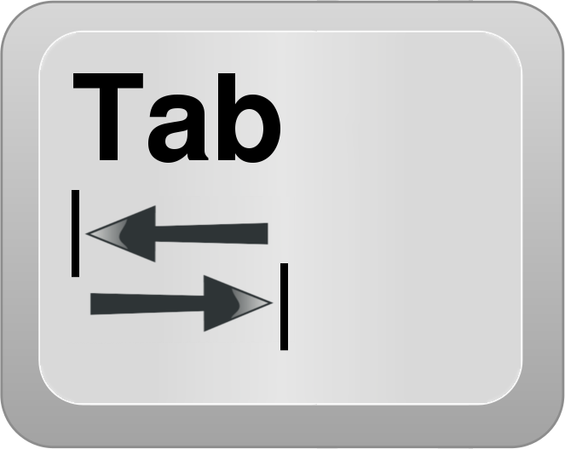

After ‘Travel Mode’ is activated, press one of the following keys to travel to each respective planetary body:

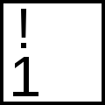 | Mercury
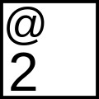 | Venus
 | Earth
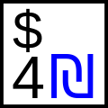 | Mars
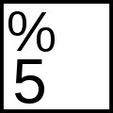 | Jupiter
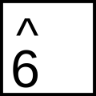 | Saturn
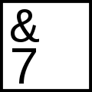 | Uranus
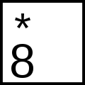 | Neptune
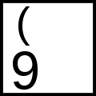 | Sun
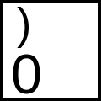 | Pluto

Rotating Planets
Press and hold the right mouse button. Drag the mouse around to rotate the planet.

Zooming In on Planets
Press and hold the ‘Home’ key to zoom in on a planet. Careful though, there is no limit to how far in you can zoom. Mixing keyboard zoom with motion zoom may make the planet too close to look at. Simply travel to another planet (or travel to the planet you are currently on) to get the zoom back to default.

Zooming Out from Planets
Press and hold the ‘End key to zoom out from a planet. Careful though, there is no limit to how far away you can zoom. Mixing keyboard zoom with motion zoom may make the planet too far away to look at. Simply travel to another planet (or travel to the planet you are currently on) to get the zoom back to default.

Speech

Traveling to Different Planets
Before traveling to different planets, ‘Travel Mode’ must be activated. To activate ‘Travel Mode’, say the phrase “Travel To” and wait for Celestia to display the words “Travel Mode” on the screen.

After ‘Travel Mode’ is activated, simply say the name of the planet you would like to travel to.

“Travel To…”
“Mercury”
“Venus”
“Earth”
“Mars”
“Jupiter”
“Saturn”
“Uranus”
“Neptune”
“Sun”
“Pluto”

Motion

Rotating a Planet
Rotating a planet with your body works the same way as rotating a planet with the mouse! Your left hand acts like the mouse button, and your right hand controls the mouse movement.

First, raise your left hand above your head to “click” the planet.
Then, move your right hand around to “drag” the planet and rotate it.
Simply lower your left hand to stop rotating.

Zooming In on a Planet
To zoom in on a planet, stretch your arms out in front of your body (at chest level) and keep your hands close together. Space Adventure is configured to not let you get too close or too far away from a planet, and will stop zooming if that limit is reached. If you really want to zoom further in, see Zooming In under Keyboard/Mouse

Zooming Out from a Planet
To zoom out from a planet, stretch your arms out to the sides of your body, so that your arms and torso make a T shape. Space Adventure is configured to not let you get too close or too far away from a planet, and will stop zooming if that limit is reached. If you really want to zoom further out, see Zooming In under Keyboard/Mouse

